

Aditya Raj

BCIS309 – Work Integrated Learning Project,

Software Development Pathway

Semester 1, 2021

SQL Test Automation for Ara Institute of Canterbury

Final Academic Report – Version 1.0

Table of Contents

Document Control 3

Introduction 4

Project Details 5

Project Name 5

Overview of Industry Client 5

Project Overview 5

Project Scope 7

Project Goals 7

Benefits of Project 9

Project Requirements 9

Expected Deliverables 10

Stakeholder Management 12

Project Hierarchy 12

Reporting and Meetings 12

Student Skills 13

Skills Required 13

Approach to Learning New Skills 13

Project Plan – High Level 14

Phases 14

Timetable 15

Burndown Charts 16

Resources/Access Required 16

Risk Management 17

Approach 17

Risk Table 17

Quality Assurance 18

Approach 18

Quality Assurance Table 18

Test Plan/Scenario/Cases 18

Methodology Summary 20

Agile Scrum Methodology 20

Ethics 21

Relevance of ITP Code of Ethics 21

Relevant Legislation 22

Privacy/Confidentiality 22

Copyright 22

Patents 22

Sustainability, Inclusive Practice and Te Tiriti O Waitangi 23

Relevance of Principles to Student and Industry 23

Reflections 24

Approach 24

Level 6 and Level 7 Course Evaluation 24

Overall Reflection 27

Self-Evaluation 28

References 29

Appendices 30

Appendix A – Project Goals 30

Appendix B – Academic Final Deliverables 33

Appendix C – Student Skills 34

Appendix D – Burndown Charts 37

Appendix E – Risk Management 39

Appendix F – Quality Assurance 42

# Document Control

|  |  |  |  |
| --- | --- | --- | --- |
| Date | Author | Version | Status of Document/Updates Made |
| 22/03/2021 | Aditya Raj | 0.1 | Document Creation – Project Proposal |
| 30/03/2021 | Aditya Raj | 0.2 | 1st Draft – Project Proposal Complete |
| 04/04/2021 | Aditya Raj | 0.3 | 2nd Draft – Project Proposal Complete |
| 06/04/2021 | Aditya Raj | 0.4 | 3rd Draft – Project Proposal Complete |
| 07/04/2021 | Aditya Raj | 0.5 | Final Version – Project Proposal Complete  Submitted to Moodle Dropbox |
| 13/05/2021 | Aditya Raj | 0.6 / 0.1 | Document Updated – Halfway Report |
| 19/05/2021 | Aditya Raj | 0.7 / 0.2 | 1st Draft – Halfway Report Complete |
| 21/05/2021 | Aditya Raj | 0.8 / 0.3 | Final Version – Halfway Report Complete  Submitted to Moodle Dropbox |
| 17/06/2021 | Aditya Raj | 0.9 | Document Updated – Final Report |
| 25/06/2021 | Aditya Raj | 1.0 | 1st Draft – Final Report Complete |

# Introduction

This report serves to describe the entire process of the SQL Test Automation project including the growth I have made from the project proposal document and the halfway report. In this final report, I will be describing the milestones that I have achieved along with this project as well as the many problems that I encountered and eventually resolved. The report will also evaluate the relevant level 6 and level 7 courses that I completed in my degree, a final reflection and the lessons learnt and a self-assessment with justifications of my progress in this project.

This document has been divided into sections, including the project details, project scope, stakeholder management, student skills, project plan, risk management, quality assurance, methodology summary, ethics, relevant legislation, sustainability, inclusive practice, Te Tiriti O Waitangi, and the reflections. Finally, the references and appendices sections are located at the end of the document.

# Project Details

This section serves to provide an overview of this project including information regarding the industry client and the project purpose and background.

## Project Name

SQL Test Automation

## Overview of Industry Client

The tutors of the Department of Business and Digital Technologies (formerly Department of Enterprise and Digital Innovation) at Ara Institute of Canterbury in Christchurch, New Zealand are the industry clients of this project. The targeted users of this project outcome are tutors of SQL Server databases courses at the organisation.

## Project Overview

### Proposed Situation

The purpose of this project has been to deploy a product that allows students in database courses in computer labs at Ara Institute of Canterbury to submit their SQL Server language code work and get automated marks and feedback instantly. This is important to the industry clients, the tutors of these databases classes at Ara, because by using this product they will be able to save many weeks not having to manually download all their students work to execute and manually mark and provide feedback, also their students will not have to wait many weeks to get their marks and feedback returned, therefore time is saved, and manual work is automated.

### Halfway Situation

According to the project proposal document, the completed product which will be deployed will be used by the students of database courses in computer labs at the institution, however, this may change depending on the outcome of the product, for example, a front-end user interface will need to be developed for students to use to get their marks and feedback returned, but if this is not possible with SQL Server and tSQLt, the tools and technologies involved, then an alternative product will be deployed which will only be used by the tutors of the classes to automatically mark each student work whist providing feedback, this information can then be shared with students. Even with this alternative outcome, the process still involves the purpose of saving time and manual work becoming automated.

### Final Situation

Moving on from the halfway situation of this project, the final situation is slightly different. At the end of the project, the developed product does successfully provide a front-end user interface while using all the underlying functionality of SQL Server and tSQLt framework, however, it is designed for the use of the database class tutors instead of the students, this is because the product allows for the model answer to be uploaded, students would be able to see the answers of the test defeating the purpose of testing their answers if they use the product.

The final product has been developed to bulk mark multiple students’ work automatically and in approximately one minute, this allows for the tutor to save 10 working days in manual marking. The user interface allows the tutor to do the following:

* Connect to the local SQL Server with the database used for the practical test.
* Upload a model answer script which will be used to compare with the student answers.
* Upload the tSQLt testing script which makes the program work by doing the comparison between the model and student answers.
* The tutor can then select a single directory with all the student answer SQL files, which the program uploads and executes once by one and outputs the results in a new subdirectory named “StudentAnswerResults”. The results are outputted as text files.
* With the click of the “Open Student Results” button, the tutor can then review those text files which contain the student results and feedback for the incorrect answers.
* Please see the attached “Product Manual” documentation for more information regarding system requirements and how to use the product.

Figure 1 SQL Test Automation Program Process

# Project Scope

This section serves to outline the industry and academic goals that were set in my project proposal document, the progress made up till the halfway report and then the final academic report to achieving these goals. This section also covers the skills I required and the areas I have worked on.

## Project Goals

### Proposed and Halfway Industry Goals

With the progression of this project, I have learnt new skills and now better understand the tools and technologies needed for the development of this project’s product outcome. I have learnt and have been able to meet my industry goals, however in the way that was possible with the tools and technologies needed.

#### First Goal

For the first goal, I expected to receive results such as YES or NO depending on the SQL Server code submitted as a student, however using Microsoft SQL Server and tSQLt, the database unit testing framework needed for the development for the product, I was able to get results such as SUCCESS or FAILURE or ERROR, although these were similar results to what I expected, the overall goal was changed according to these results.

#### Second Goal

At the halfway stage of the project, I had not been able to provide a platform for students to use to self-mark their work according to the second goal in my project proposal which is to allow the student to self-mark without being revealed the correct answer, however, I have been able to write tSQLt unit tests that allow for results to be displayed only, without revealing the correct answer to the student (only if they do not investigate the RAW product code). In future increments of my product, my new industry goal is to add a front-end platform for students to use or if this does not work, an alternative goal is to provide a product for the tutor to use to automatically mark each student work whist providing feedback, this information can then be shared with students.

#### Third Goal

My third industry goal was to present feedback with the results of the tests, in which the student would receive feedback as to why their work is correct or not correct. At the halfway mark of this project, I have been able to develop the product outcome which shows some feedback including missing records of query tables, missing tables/objects, or simply WRONG ANSWER to the most unexpected results.

Appendix A1 shows evidence of these proposed and halfway industry goals’ outcomes.

### Final Industry Goal Outcomes

My industry goals have changed over time depending on the situations of the project. As per my halfway goals, these were altered proposed goals, however, the second goal has changed again by the final situation of this project:

#### First Goal

The first goal has been to get results such as SUCCESS or FAILURE or ERROR for each student answer/query, this has not changed, and the goal has been met in the final product.

#### Second Goal

The second goal has been to provide the student with a program with a user interface which they would use to test their work and get results and feedback *OR*provide a product for the tutor to use to automatically mark each student work whist providing feedback, this information can then be shared with students. The alternative idea of the goal has been implemented, the product has been designed to be used by the tutor who will use the program to automatically test the student work and share the outputted results with feedback with the student.

#### Third Goal

My third industry goal has been to present feedback with the results of the tests, in which the student would receive feedback as to why their work is correct or not correct. At the halfway mark of this project, I had been able to develop the product outcome which shows some feedback including missing records of query tables, missing tables/objects, or simply WRONG ANSWER to the most unexpected results. This goal's outcome remains the same in the final product, the outputted results still provide results and feedback in this way for each student.

Appendix A2 shows evidence of these final industry goals’ outcomes.

### Proposed and Halfway Student Goals

My goal as a student working on this project has been to develop an understanding of how to use tools and technologies that are needed for the development of the product outcome, I included tSQLt, the database unit testing framework for SQL Server in my project proposal, and this has been true, I have had a difficult time understanding this technology that is very new to me as well as the use of Microsoft SQL Server Management Studio 18. At the beginning of the project during Sprint 1, I spent many hours simply following tutorials and manual documentation of these tools and technologies to understand and familiarise myself with them so that I can efficiently work on developing my product outcome. As per my project proposal, my overall student goal is still, to successfully produce a deployable final product for this project.

### Final Student Goals Outcome

My student goal of developing an understanding of tools and technologies needed for the development of the product outcome has been ongoing throughout this project. I had started using SQL Server, the tSQLt testing framework and Microsoft SQL Server Management Studio from the beginning, and now at the final stage of this project, I have gained many skills and have broadened my knowledge of these tools and technologies, I have also been able to achieve my student goal this way.

In the sprints past the halfway report, I started using Microsoft Visual Studio 2019 with programming language C# and Microsoft .NET framework to develop the front-end user interface for the product outcome. Since I had used these tools and technologies in past courses, I was familiar with their use, however by using these in the implementation of the product outcome, I was able to broaden my knowledge and skills in this area as well, I was able to produce a fully functioning and usable final product which is how I was able to not only achieve this student goal but also my overall student goal of successfully producing a deployable product outcome.

I will be discussing the problems I faced and how I resolved them in the Reflection section and the Level 6 and Level 7 Course Evaluations section of this document.

## Benefits of Project

### Industry Benefits

The industry will benefit from this project by using a deployed product that saves a lot of time for both the tutors and the students where marking is automated and instant. As per the project proposal and halfway report, this benefit remains unchanged, and I have been able to deliver this benefit at the final stage of this project.

### Student Benefits

As a student working on this project, I hoped to benefit by having developed new skills using SQL Server and tSQLt framework within, this benefit as per the project proposal and halfway report also remain unchanged as I have developed many new skills throughout this project which will help me progress further in my IT career.

## Project Requirements

In my project proposal document, I had the following requirements, these are ways I progressed through them up till the halfway and then the final stage:

* Use of tSQLt framework and SQL Server 2017 and 2019 to test product across both versions in an event of a system-wide upgrade – testing has been done using both versions on Ara computers (more about this in the Testing Phase of the Project Plan section).
* The product must work in room X205 at Ara Institute City Campus, other rooms may have the product deployed in the future – testing has been done in X205 as well as other computer labs at Ara (more about this in the Testing Phase of the Project Plan section).
* The product must compare the student work with the model answer provided by the tutors, looking and comparing specifically at the fields, data, order, and tables in the SQL code files – the product does this successfully while providing a result and feedback for each student after bulk marking (more about this in the Development Phase of the Project Plan section).

## Expected Deliverables

### Industry Proposal and Halfway Deliverables

As per my project proposal, in my halfway report, my four deliverables for this project were on track to be completed, as I had done the following in development:

* The product marks student work from a directory (executed script with student code) and provides a correct or incorrect result.
* The product provides some words for feedback as to why the work is incorrect.

### Industry Final Deliverables

The following were future deliverables that were expected to be completed by the end of the project:

* The product allows students to self-mark, but without revealing to them the answers OR tutor uses the automated product to retrieve marks for the student work.
* The final deployable product without errors or bugs ready to use.

However, these are the actual final deliverables of the project:

* A portable Windows program called SQL Test Automation serves to automate the bulk marking of SQL Server practical tests done by the students of database courses at Ara Institute of Canterbury. This program has been developed to speed up the marking process for tutors of SQL Server database courses in which student work is marked automatically and instantly, not only reducing time and manual work for tutors, but students also benefit by receiving their results much faster. This program reduces the time taken to mark a class of 25 students work from 10 working days, down to approximately 1 minute.
* As of now, all errors and bugs have been fixed and the product is ready for use.

### Academic Proposed and Halfway Deliverables

These are the academic deliverables for this project that I had completed up till the halfway report, taken from the project proposal but also with deliverables not mentioned before:

* Project Proposal & WIL Agreement
* Halfway Report
* Part A of Methodology Essay
* Academic Supervisor Halfway Assessment
* Industry Supervisor Halfway Assessment
* Weekly Meeting Reports
* Student Photo

### Academic Final Deliverables

The following academic deliverables have now been completed as of this final report being published:

* Summary Profile Document
* Final Academic Report
* Final Methodology Essay (Parts A, B & C)
* Panel Project Poster
* Panel PowerPoint Presentation
* Emerge Exhibit Poster

Appendix B1 outlines the timeline the deliverables for both industry and academic were submitted throughout this project.

# Stakeholder Management

This section covers the information about the individuals involved in the project including the course convenor, industry supervisors and academic supervisors. I will also be covering how I have managed to communicate with them throughout this project.

## Project Hierarchy

The people directly and indirectly involved in this project are:



Figure 2 Project Hierarchy Diagram

## Reporting and Meetings

According to the project proposal document, the main option of communication between meetings has been via emails and this has continued throughout the project as this has been an effective way to communicate digitally. For reporting, I have had meetings with my industry supervisors, Amit and Alister, almost every week when appropriate as per the sprint cycles. Meetings with my academic supervisor, Rob Oliver, has been every Friday at noon. More about these meetings will be discussed in the project planning section of this document. I have also attended class sessions with the course convenor, Dr David Weir, on Mondays and/or Thursdays from 3-5 pm.

# Student Skills

The skills needed for the project to effectively make use of the tools and equipment to complete the tasks that are scheduled for use and completion are covered in this section.

## Skills Required

As per the project proposal document, the following general and ICT specific skills were required, and these are the ways I made use of tools and technologies to complete tasks throughout the project:

|  |  |
| --- | --- |
| Skills | Tools and Technologies Used |
| Project Management and Organisation | I used an online tool called Trello to organise my tasks and manage my time, this application was helpful because it helped me visualise what I needed to do and when, please see Appendix C1 for evidence. I also used Microsoft Excel to complete the task planning for sprints (more about this in the Project Planning section of this document). |
| Time Management | I used an online tool called Toggl Track to keep track of my time and manage it for both industry and academic work. I found this application helpful because it made it easy for me to make sure that I met weekly hour goals, see Appendix C2 for evidence. |
| Teamwork | Although I mentioned this in my project proposal, as a project of one, teamwork as a skill was not needed when coding, however, communication with my supervisors did involve some teamwork when testing. |
| Communication | I used Microsoft Outlook email to communicate with my industry and academic supervisors between meetings. I found this application useful because it offered me instant email notifications which provided me with date information and helped me reply instantly. |
| Report Writing and Documentation | I used Microsoft Word for writing reports such as this and Microsoft Excel for my Sprint Backlog (more about this in the Project Planning section). |
| Code Repository | I created a private GitHub repository and shared it with my industry supervisors for version control and code management, all my sprints can be found here. This is something that was not mentioned in the project proposal. See Appendix C3 for evidence. |

For the evaluation of the skills, I gained in level 6 and level 7 courses in my degree, please see the Level 6 and Level 7 Course Evaluations section in this document.

## Approach to Learning New Skills

As per my project proposal, I had mentioned that I would use time outside the hours of working on the project to learn new skills, however, I had to spend a lot of time while working on the project to learn the skills required such as the tSQLt framework and SQL Server language for me to start and progress with the sprints. I used the specific tools or technologies official documentation such as the Microsoft documentation for T-SQL language, C# language and .NET framework to figure out how to make use of them for the project product outcome.

# Project Plan – High Level

This section serves to focus on the planning that was done in the project proposal as well as what was done up till the halfway stage and finally to the completion of the project. This section involves the steps taken at each phase of the project including resources consumed and the time taken to complete the project.

## Phases

Following the project proposal, the project involves the use of the Agile Scrum methodology, each sprint consists of six phases for software development, the following graph shows the phases throughout each sprint (MacKay, 2019):

Figure 3 Software Development Process

For this project, I have completed these phases for each sprint. At the beginning of each sprint, I met with my industry supervisors to discuss goals, requirements, and the outcomes of what they need at the end of the sprint, as per this I was able to plan for what I needed to work on, I included the discussed requirements in a “Industry Backlog” excel spreadsheet.

The design and development phases were established by coding the product which involved Microsoft SQL Server 2017 and 2019, and tSQLt database unit testing framework within SQL Server, which allows for the implementation of unit tests in T-SQL, a proprietary extension to the SQL Server language.

I did manual testing while coding the product throughout the development phase, it was also tested by my industry supervisors during our sprint meetings which also involved the evaluation of the product for the next steps. The following sections explain these phases in greater detail with evidence of my work with steps taken according to (MacKay, 2019).

Please read my Methodology essay for the full breakdown of my use of the Agile Scrum Methodology with all evidence provided.

## Timetable

I had been provided with a requirement of at least 300 industry hours and 150 academic hours (a total of 450 hours for the project) to complete the project in total, in my project proposal I had estimated 30 hours of industry hours weekly and 9 academic hours weekly for the project only, I have attempted to meet these goals every week till the halfway stage, however after that since I quickly completed 150 hours of academic work, I increased my total academic hours to 200, this made my new weekly goal 11 hours. My industry total of 300 hours did not change and by the final stage, I had passed this requirement, including my new academic hours' requirement – more on this in the Burndown Charts section. I also had to balance my other coursework for BCDE321 Advanced Programming, a part-time job, family, and community commitments. This is an estimate of how my weekly timetable looked like:

|  |  |  |  |  |  |
| --- | --- | --- | --- | --- | --- |
| Monday | Tuesday | Wednesday | Thursday | Friday | Saturday |
| Between  6 am – 2 pm  Industry Work | Between  6 am – 5 pm  Industry Work | 10 am – 12 pm  Advanced Programming Class | Between  6 am – 4 pm  Advanced Programming Work | Between 6 am – 11 am  Academic Work | Between 6 am – 6 pm  Industry Work |
| 3 pm – 5 pm  WIL Session | 6 pm – 10 pm  Community Commitment | Between  1 pm – 2 pm  Industry Meeting | 5 pm – 9 pm  Part-Time Job | 12 pm – 1 pm  Academic Meeting | 6 pm – 12 am  Family Commitments |
| Between  6 pm – 12 am  Industry Work | Between  10 pm – 12 am  Industry Work | Between  3 pm – 12 am  Academic Work | Between  10 pm – 12 am  Advanced Programming Work | 1 pm – 3 pm  Advanced Programming Class |  |
|  |  |  |  | 4 pm – 11 pm  Part-Time Job |  |

Depending on the week, I prioritize certain industry and academic work and do them when appropriate or possible during the week.

## Burndown Charts

### Industry Burndown

Please see appendix D1 for the full industry burndown chart completed for the project. My weekly goal for industry hours has been 30 hours, the lowest I achieved was 17 hours in the first week of the term break and the highest I achieved was 34.5 hours in week 10.

### Academic Burndown

Please see appendix D2 for the full academic burndown chart completed for the project. My weekly goal for academic hours has been 9 hours, the lowest I achieved was 3 hours in the first week of the term break and the highest I achieved was 45 hours in week 6 (this week I had not started my industry work and was completing my project proposal).

## Resources/Access Required

As per my project proposal, I had mentioned the need for access to rooms N209 and X205 at Ara Institute, City Campus because it is a requirement that the final product is deployed in X205 and to test this, this room needs to be used. N209 was to be used to work on the code. I also required access to a computer running SQL Server 2017 and 2019 for the testing of the product on both versions because it is a requirement that the deployed product be executable on both versions, whichever is installed on a specific computer.

From the project proposal, I have worked on my industry code at Ara in various computer rooms for testing and on my laptop, I have also tested the product with my industry supervisor on an Ara account with Staff privileges and an Ara account with Student privileges.

# Risk Management

Risks may be present or may arise during the runtime of the project, this section covers these risks including their solutions or methods of mitigation. The initial risk management was done in the project proposal, the mid-stage was done in the halfway report and this final report investigates the final stage of risk for the project.

## Approach

The risk table features a list of risks that could arise during the runtime of the project. The table explains the condition of the risks, their consequence, their probability, impact and exposure measurements, their mitigation strategy, their contingency, and triggers. There is a range of variables present in each of the risks documented, they have been identified in the risk table. These risks will be reassessed in this final report for the completion of the project.

## Risk Table

The initial, mid, and final stage risk management tables can be found in Appendix E1 to E3 of this document. These tables each feature 5 risks covering various types of risks that may arise during the project ordered from the highest to lowest exposure rating.

The risk management table has been derived from the Microsoft Risk Template Tool. The risk probability is the likelihood of a risk condition occurring, it must be between 1% and 99%, that is 1% to 30% for low risk, 31% to 70% for medium risk and 71% to 99% for high risk. The impact value is the effect of the risk consequence which must be between 1 and 10. I have selected my values dependent on the history, previous occurrences, and my experience of these risks, with my estimation of these risks, occurring. The exposure value is calculated by multiplying risk probability with risk impact, the table is sorted from highest exposure to lowest exposure to prioritize risks.

### Initial to Mid Stage Risk Changes

From the project proposal initial stage table, the main changes in the halfway report mid-stage table were the decrease in exposure to the condition of COVID-19 Alert level change, this has gone from 1.05 down to 0.25 because of the continued zero community cases in New Zealand. While the chance of me getting sick has increased from exposure 1 to 1.8, this is because of the winter weather arriving now. The highest risk that remained at #1 is not meeting submission deadlines due to the increased workload at the halfway mark of this project.

### Mid to Final Stage Risk Changes

From the halfway report mid-stage table to the final report final stage table, the main changes were to the decrease in exposure to the condition of COVID-19 Alert Level change which has gone from 0.25 down to 0.09, due to the continued zero community cases in New Zealand. Also, I did get sick in the final weeks of the project, therefore the Sickness condition exposure increased from 1.8 to 4.8, however since I was able to manage my time and complete deadlines on time, this did not increase the “Not meeting submission deadlines” condition even though it is still the highest risk on the table.

# Quality Assurance

Steps must be taken to ensure that the project meets the prerequisites that have been requested and that these are at an expected standard. This section covers the processes that have been set up within the industry to fulfil these quality assurance requirements.

## Approach

For the quality assurance of my code and outcomes produced, my approach has been to adhere to official online manuals and tutorials of tools and technologies that I use, for example, tSQLt which is a testing framework and the SQL Server language, I have made sure to write code that is of best programming practices by adhering to the Microsoft online documentation and tSQLt official full manual.

* All SQL code has also been validated and formatted using the Microsoft SQL Server documentation.
* All tSQLt code has been formatted using the tSQLt testing framework manual.
* All C# and .NET framework code has been validated and formatted using built-in Microsoft Visual Studio 2019 cleaner.

## Quality Assurance Table

The quality assurance table can be found in the Appendix F1 section of this document. It covers a list of all deliverables, the criteria for acceptance and who all accept them.

## Test Plan/Scenario/Cases

During the writing of code, I made sure to use the Microsoft SQL Server documentation to check, validate and format SQL Server language code, I used the tSQLt official full manual to check, validate and format the test classes and all other code and I used Microsoft Visual Studio 2019 and its built-in cleaners to check, validate and format my C# language and .NET framework code.

At the end of every sprint, my industry supervisor checked and tested my work, this is a way the quality of the code is reviewed, by a qualified person. The product produced is tested using unit tests and manual testing in which my industry supervisors Amit and Alister did functional and usability testing to evaluate changes for the next sprint.

The final sprints were also tested by external professionals in the IT industry such as the Ara ICT Service Desk and Ara’s graduate Alliah Calla. They had provided excellent feedback for the product. Support has been also provided from the Ara ICT Service Desk to deploy the product.

Please read my Methodology essay for the full breakdown of the Testing phase.

The interrater reliability of the product has also been tested using Cohen’s kappa statistics. The purpose of this is to gain the degree of agreement among raters, in this products case, the tutor users Amit, Alister and Rob. The following table shows the calculation of per cent agreement between the raters in comparison to the program doing the marking for them:

|  |  |  |  |  |  |
| --- | --- | --- | --- | --- | --- |
| **Question #** | **Raters** | | | | **% Agreement** |
| ***Program*** | ***Amit*** | ***Alister*** | ***Rob*** |
| 1 | 1 (Success) | 1 | 1 | 1 | 1.00 |
| 2 | 0 (Failure) | 0 | 0 | 0 | 1.00 |
| 3 | 0 (Error) | 1 | 1 | 1 | 0.75 |
| 4 | 1 (Success) | 1 | 1 | 1 | 1.00 |
| 5 | 0 (Failure) | 0 | 0 | 0 | 1.00 |
| 6 | 0 (Error) | 0 | 0 | 0 | 1.00 |
| 7 | 1 (Success) | 1 | 1 | 1 | 1.00 |
| 8 | 0 (Failure) | 0 | 0 | 0 | 1.00 |
| 9 | 0 (Error) | 1 | 1 | 1 | 0.75 |
| 10 | 1 (Success) | 1 | 1 | 1 | 1.00 |
| **Study Interrater Reliability** | | | | | **0.95** |

The interrater reliability is greater than 90%, therefore in this case our finding shows that it is a very high level of reliability with Amit, Alister and Rob as the markers (raters). This result proves the reliability of the program in terms of the results it produces, therefore the program meets quality assurance requirements.

# Methodology Summary

This section serves to summarise the Methodology essay with a discussion involving the implementation of the Agile Scrum Methodology in this project.

## Agile Scrum Methodology

The SQL Test Automation project at Ara Institute of Canterbury involves the use of the Agile Scrum methodology, an incremental development framework that allows for teams to collaborate while working on complex projects. This project applies the Agile Scrum methodology because of its many advantages that help satisfy the requirements of the company project unlike other methodologies such as the Waterfall which because of its linear process does not allow for constant improvement and innovation for products in the ever-changing software market (Muslihat, 2018).

With the Agile Scrum methodology, I was able to work in increments, by adding required features and making changes to the product in each sprint as per feedback from my industry supervisors. This methodology has been easy to understand and has allowed me to prioritize important features over features that will never be used. I have put into practice these steps of the process according to (Business News Daily Editor, 2020).

### Meeting and Planning

The first phase involves meeting your customer or stakeholder to analyze and plan for the project or sprint. The planning should include the connection of the project to the company’s goals, the resources and time required, the scheduling of tasks and cost estimation. Everyone involved in the project will need to be accounted for in the planning for the project to start efficiently. The planning will also involve the requirements, which includes the details of the product, the reasoning behind it and how it will come together according to the client (MacKay, 2019)

### Designing and Development

With the planning and requirements complete, the design and development can begin, this could include prototypes, user stories, wireframes, etc. The development of the software can then begin keeping in mind to avoid scope creep and building clean and efficient software according to the planning, requirements, and designs (MacKay, 2019)

### Testing and Evaluation

Testing can happen during the development phase while keeping track of bugs and errors. Once the features are complete and the product is ready, more in-depth testing is recommended before moving forward. Evaluation can happen and changes can then be issued for the next sprint. The process then restarts for the next sprint.

Please read my Methodology essay for the full breakdown of my use of the Agile Scrum Methodology with all evidence provided.

# Ethics

There may be ethical issues involving the project and its completion, this section outlines these ethical issues that may arise and how they will be dealt with.

## Relevance of ITP Code of Ethics

These ethics have been outlined as per reference (IT Professionals New Zealand):

### Good Faith

With good faith, people must be treated with dignity, equality, be without discrimination, be considered of, and the values and cultural sensitivities of all groups in the community affected by the work being conducted in the project.

### Integrity

With integrity, people must behave with honour, dignity, and integrity to be worthy of the trust of the profession and encourage it within the community. To apply appropriate judgement, apply honesty and exercise initiative to participate positively in the well-being of the public in general and the project.

### Community Focus

Before your responsibility to the profession and interests whether sectional or private, the prosperity of the community must come before the project.

### Skills

Without the settlement of other tenets, skills and knowledge are to be applied in the interest of the client/employers for/on behalf of whose actions are done for the project.

### Continuous Development

While promoting the collective wisdom of the profession, members of the team will continue to develop knowledge, skills and expertise during their careers while doing their best to actively promote their peers to do the same, for the project.

### Informed Consent

To remain informed, there should be steps taken. Clients, employers of the economic, social, environmental, or legal consequences may arise from actions carried out during the project.

### Conflicts of Interest

Clients shall be informed if there are any conflicts of interest, of which there is the observation of, between the work shown and the awareness of the client or employee, which can undesirably affect the work done in the project.

### Competence

Professional practice should be obeyed, as well as services delivered and advice thoroughly and carefully, within the areas of competency for the project.

# Relevant Legislation

## Privacy/Confidentiality

Regarding the project, the product that is developed will need to collect Ara Institute student information such as full name, student ID number, etc., as well as the course code and assessment number of the work they are submitting for automated marking. As per these requirements, The Privacy Act 2020 will be considered to make sure that the student information and work stay private and only for the use of marking their work via the SQL Test Automation product.

## Copyright

Efforts will be made to create original work for the project, if for any reason, other people’s work is needed, they will be appropriately asked for permission and acknowledged, and this will be done according to the copyright license they have given their work. The product developed part of this project will only be made available within Ara Institute for private use by students and tutors only, it will not be used publicly or outside Ara Institute.

## Patents

The product because of this project may or may not be patented by the industry supervisors at Ara Institute as it is for use only within Ara Institute. If patented, this will stop others from making, using, or selling the product for up to 20 years and the rights will exist within the Canterbury region.

# Sustainability, Inclusive Practice and Te Tiriti O Waitangi

The four principles that must be obeyed during the runtime of the project are covered in this section. Their meanings will be covered.

## Relevance of Principles to Student and Industry

### Kaitiakitanga

For work to be carried out and completed, there should not be any personal issues and waste to the company resources that have been provided by the industry sponsor for the project. The reputation of the industry sponsor is reflected by this. The attitudes in the workplace and the personal reputation as a worker.

### Rangatiratanga

Any decisions or choices made concerning the project must be correctly assessed and adhered to the resources made ready, also including taking opinions of other team members and the industry supervisor.

### Whanaungatanga

The industry supervisor must be consulted to ensure that tasks are being carried out in order and within the set expectations. All reporting done in the team means that all team members part of the project understands what is happening so that they can assist when needed, doing this ensures that relations grow within the team.

### Mana Reo

Efforts should be made to ensure that the use of Te Reo or other languages is being accommodated by the team members on the project.

# Reflections

The following section grows from the project proposal and the halfway report now features reflections from throughout the project. Also included are the level 6 and level 7-course evaluations.

## Approach

For the reflection of lessons learnt during the runtime of this project, notes have been taken by writing down what needs to be worked on for next time, this includes what changes need to be made before work beginning to avoid future mistakes or liabilities. Time has been taken out to reflect on what is happening and what can be done so that work can happen easier or more efficiently. Work should be done by saving time and resources, these reflections have helped with that in mind.

## Level 6 and Level 7 Course Evaluation

The following Level 6 and Level 7 courses that I completed in my degree have helped me in this project:

### BCPR203 Database Management Systems

#### Identification of Course Content

* MySQL database language.
* Create database, create tables, insert data.
* Use queries, stored procedures, views, etc.
* Design, develop, implement, and use relational databases.

#### Evaluation

As a student who had an interest in databases and had never worked with the database language MySQL, this course was exciting. I enjoyed learning about the various ways relational databases were designed, developed, implemented, and used. The power of queries, views, stored procedures, etc. with relational databases amazed me. Later in the PHP course, these new skills came in handy as they broadened and expanded my understanding of databases and their use on the server-side with MySQLi.

Although MySQL was not used in this project, another similar language named SQL Server was very important for the project product outcome. With my prior knowledge and skills with MySQL, I was able to easily make my way around SQL Server. I was able to easily work with multiple databases and schema, even though it took me time to my head around the tSQLt framework, I understood how queries and stored procedures worked, I used these skills to quickly and efficiently developed the program.

#### Recommendation

This course was the only full database course I did in my degree, I would have liked to do more of this because I enjoyed learning about databases and using them, therefore I recommend adding more databases courses maybe with other database languages.

### BCDE224 Best Programming Practices (Server-Side Programming PHP)

#### Identification of Course Content

* MySQLi database language.
* SOLID principles.
* Create database, create tables, insert data.
* Design, develop, implement, and use relational databases.

#### Evaluation

This course involved the use of server-side programming language PHP and database language MySQLi which is the PHP version of MySQL. The course content was interesting since I also enjoy creating and designing HTML and CSS websites, I got to learn the back end of websites which included how databases and other internet aspects are connected to these websites. MySQL was familiar due to my previous database course BCPR203 which involved the use of MySQL. MySQL helped create a form for user login and social media like buttons on an assessment in this course.

Since this course involved the use of databases and how they work with other languages such as PHP, I was able to take this understanding and implemented SQL Server database language with C# and .NET framework, this was like the concept of using MySQL with PHP and HTML/CSS. Similar aspects of database creation, query, stored procedure usage has been done in the project product outcome.

#### Recommendation

In this course, I would have liked to see more uses of MySQL with PHP, it would have been interesting to see more powerful uses of databases on the server-side and the internet, therefore I recommend adding more of the concept of database use with PHP into this course.

### BCDE213 Interactive Media Development

#### Identification of Course Content

* Use of interactive media design principles.
* Project management.
* Project documentation.

#### Evaluation

I enjoyed this course because I got to develop something without a set and strict requirement of an assessment, also since I enjoy design. This course involved the development of an interactive media product which was part of a project. This course did not only teach me the use of the best design practices in a product but also how to manage a project and complete documentation for it. This course included the creation of a product through a project layout, for example, initial, mid, and final documentation such as project proposal, timeline plan, navigation maps, wireframes, storyboards, risk management plan, lo-fi and hi-fi prototypes, and reports, this helped me understand how to do proper project management.

All these aspects of the course did make it easier for me to manage my capstone project, which involved a similar way of doing academic documentation such as the initial, mid, and final reports with risk management, time planning, and many more. Some of these aspects were also involved in the industry work, which is increments of work as sprints, like the incremental development processes in this course. I was also able to implement the interactive media design principles into my project product outcome when designing it using C# and .NET framework.

#### Recommendation

I enjoyed this course and have no further recommendation, it already covers a wide range of concepts and tools for design, development, project management and documentation.

### BCDE222 Best Programming Practices (C# .NET)

#### Identification of Course Content

* C# software model (back-end)
* .NET framework forms UI (front-end)
* C# syntax portfolio
* Windows game development.

#### Evaluation

This course was enjoyable because it involved the development of a Windows-based game/program using the C# language and .NET framework to create the forms UI for Windows PC. The game developed was Theseus and the Minotaur and involved the MVC structure to build it, including the model code, the view and controller of the game.

Although I did not develop a game for this project, the skills and knowledge I gained regarding the C# language and .NET framework helped me quickly and efficiently create the front-end UI for this project’s product outcome. Using the product Microsoft Visual Studio taught in this course, helped me use its tools to package my SQL Server and tSQLt framework code into one program without too much difficulty.

#### Recommendation

I enjoyed developing the game using C# and .NET framework in this course, however, I would have also liked to learn and develop Windows programs in this course, therefore I recommend that the development of Windows programs also be added to this course as this could help students broaden their knowledge and skills with these tools and technologies.

### BCIS201 – IT Solutions Deployment

#### Identification of Course Content

* System Development Methodologies
* Agile Methodology
* Scrum
* Project Failures

#### Evaluation

This was a nice IS course that first introduced me to methodologies in system development such as the waterfall model, the incremental model, Agile development, Scrum, and many more. This course also discussed the causes of project failure and how to avoid them.

I found this course useful because, with the knowledge of methodologies that this course provides, I was able to understand and successfully implement the Agile Scrum methodology, also properly document this methodology in my full methodology essay for this project. The knowledge of how project failures occur helped me avoid the failure of my project thanks to this course.

#### Recommendation

I enjoyed this course and have no further recommendation; it already covers a wide range of project concepts.

## Overall Reflection

Throughout this semester, this course, and this project, I have gone through many ups and downs whether it be in terms of skills and knowledge, time management, workload or simply the anxiety of failure. At the beginning of the course, I had not obtained a project, after many weeks of searching, attending interviews and being rejected, I was offered an internal project by Amit and Alister at Ara Institute and by my luck, it involved databases, this was lucky for me because I did enjoy working with databases, however, it was going to be a lot more difficult than I thought, I was introduced to the tSQLt database unit testing framework for Microsoft SQL Server. I had not used SQL Server before, however since I did do BCPR203 Database Management Systems, I did know how to use MySQL and this helped me gain an understanding of the SQL Server and T-SQL languages, however, I had never used a database unit testing framework before, but it turns out most people had not also since this is a newly growing technology in the database area in the IT industry.

Even though this project has been a challenge for me, I have enjoyed working on it, learning new skills, and gaining knowledge with these processes, technologies, and tools. It has been a unique experience, something that I had never done before. It is my personal goal to develop a career, which will advance my practical experience and allow me to utilize these skills to the best of my ability. I look forward to starting my career in the IT industry.

*Please read Part C of my Methodology essay for my full reflection on the project.*

## Self-Evaluation

|  |  |
| --- | --- |
| Course Management | **4/5** |
| The Project | **5/5** |
| Analysis of Relevant Level 6 and 7 Courses | **5/5** |
| Quality Assurance | **3/5** |
| Risk Management | **3/5** |
| Methodologies Essay | **4/5** |
| Report | **4/5** |
| Panel Presentation | **4/5** |
| Poster and Short Paper | **4/5** |

### Self-Assessment Justification

* **Course Management** – I have established and maintained an extensive and effective approach to the management of the course while displaying effective control and communication throughout its execution (pages 14-16).
* **The Project** – Has completed the project to the industry supervisor’s satisfaction demonstrating an exceptional grasp of the subject. Has consistently exceeded the standards required. (Pages 7-11).
* **Analysis of Relevant Level 6 and 7 Courses** – I have correctly identified and evaluated all and only relevant content of level 200 & 300 courses completed. Analysis shows course material has been applied in a thorough and useful manner. I have made perceptive recommendations about content to include. (Pages 24-26).
* **Quality Assurance** - I created, maintained, and applied a quality assurance programme for most aspects of the course, showing some understanding of how the quality assurance programme is applied. I considered the use of the programme and drawn appropriate conclusions (page 18).
* **Risk Management** - I created, maintained, and applied a risk management programme for most aspects of the course, showing some understanding of how the risk management programme is applied. I have considered the use of the risk management programme and drawn appropriate conclusions (page 17).
* **Methodology Essay & Report** – I have related well-referenced, accepted theory to the industrial practice observed while carrying out the project to a high standard. Thoughts and ideas convey intended meaning, a degree of fluency apparent. Accurate grammar and spelling. I have made a sound analysis and reflection of course performance.
* **Panel Presentation** – To be completed on 1st July 2021 at 10 am.
* **Poster and Short Paper** - Poster highly imaginatively displays project aims, outcomes and student learning. Most other elements specified are present and displayed mostly appropriately in the poster. I completed the short paper to a high standard, accurate details in all component sections and the presentation are carefully and logically organised.

# References

Business News Daily Editor. (2020, February 25). *What Is Agile Scrum Methodology?* Retrieved April 3, 2021, from Business News Daily: https://www.businessnewsdaily.com/4987-what-is-agile-scrum-methodology.html

IT Professionals New Zealand. (n.d.). *The ITP Code of Ethics.* Retrieved March 30, 2021, from IT Professionals New Zealand: https://itp.nz/Members/Code-of-Ethics

MacKay, J. (2019, October 2). *Software Development Process: How to Pick The Process That’s Right For You.* Retrieved May 3, 2021, from Plan.io: https://plan.io/blog/software-development-process/

Muslihat, D. (2018, March 2). *Agile Methodology: An Overview.* Retrieved April 3, 2021, from Zenkit: https://zenkit.com/en/blog/agile-methodology-an-overview/

# Appendices

The following appendices have been presented from the above sections of this document.

## Appendix A – Project Goals

### Appendix A1 – Proposed and Halfway Industry Goals

#### First Goal

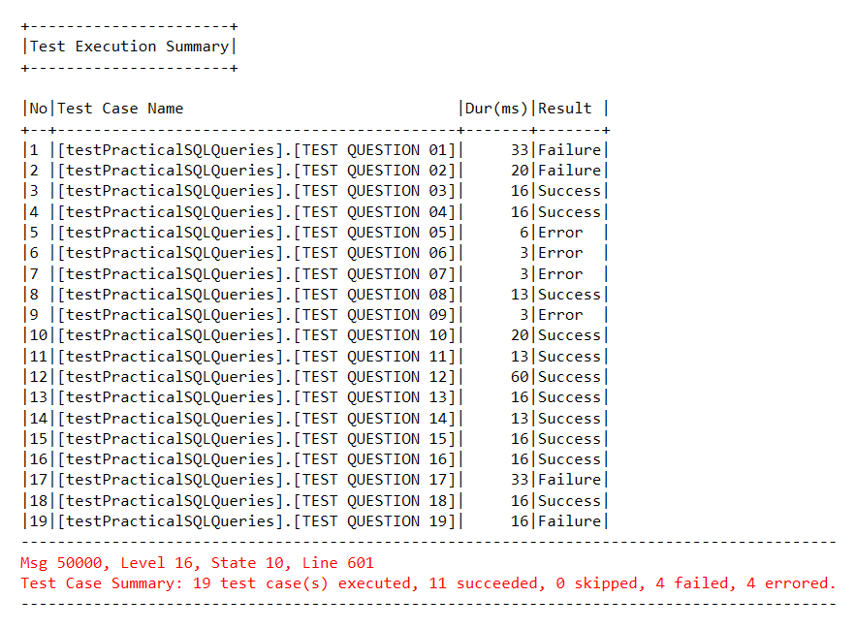

#### Second Goal

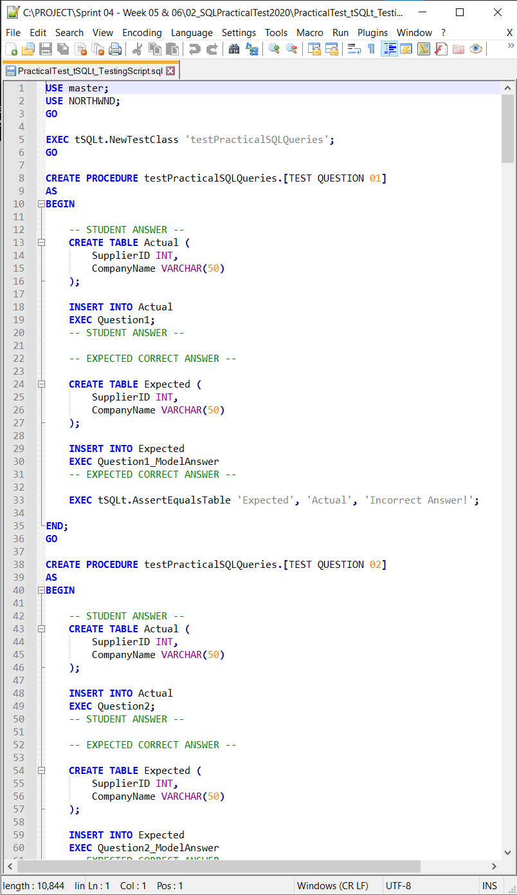

#### Third Goal

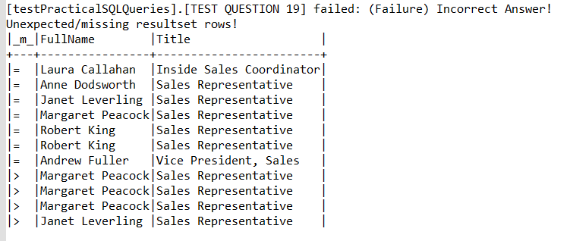

### Appendix A2 – Final Industry Goal Outcomes

#### First Goal



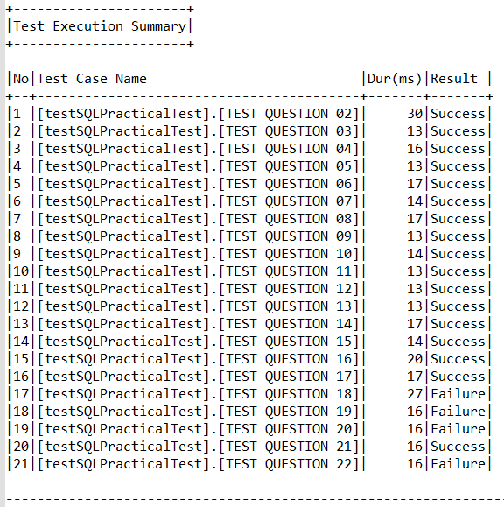

#### Second Goal

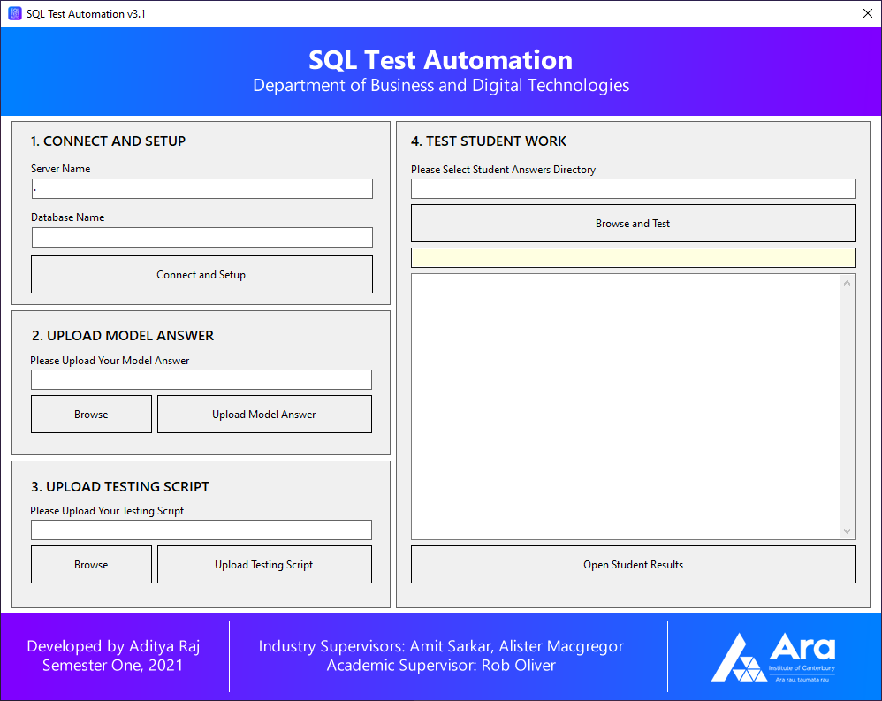

#### Third Goal

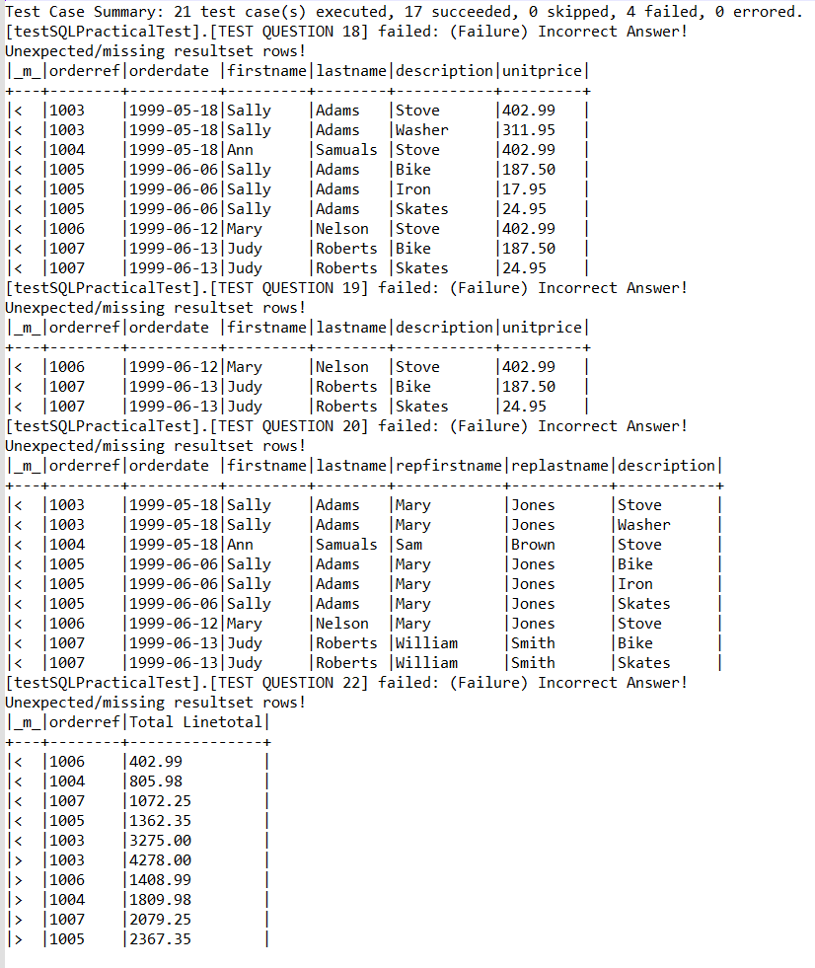

## Appendix B – Academic Final Deliverables

### Appendix B1 – Industry and Academic Deliverables Timeline



## Appendix C – Student Skills

### Appendix C1 – Trello (Project Management)

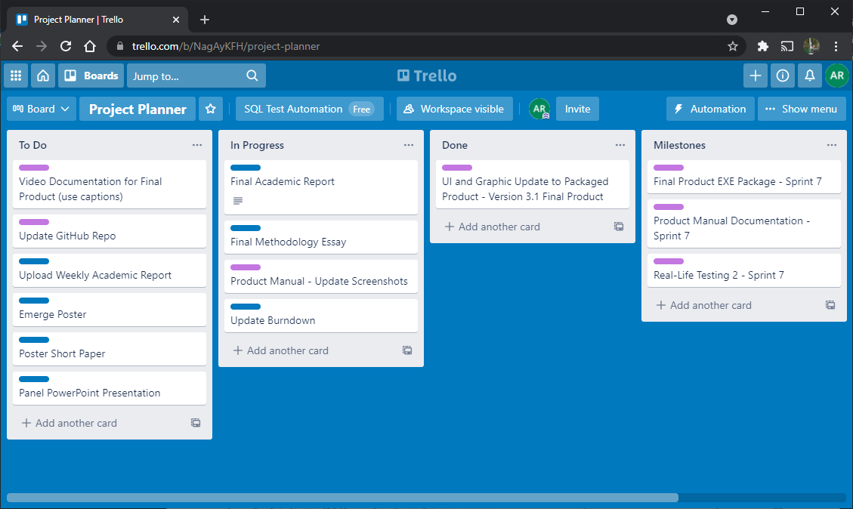

### Appendix C2 – Toggl Track (Time Management)

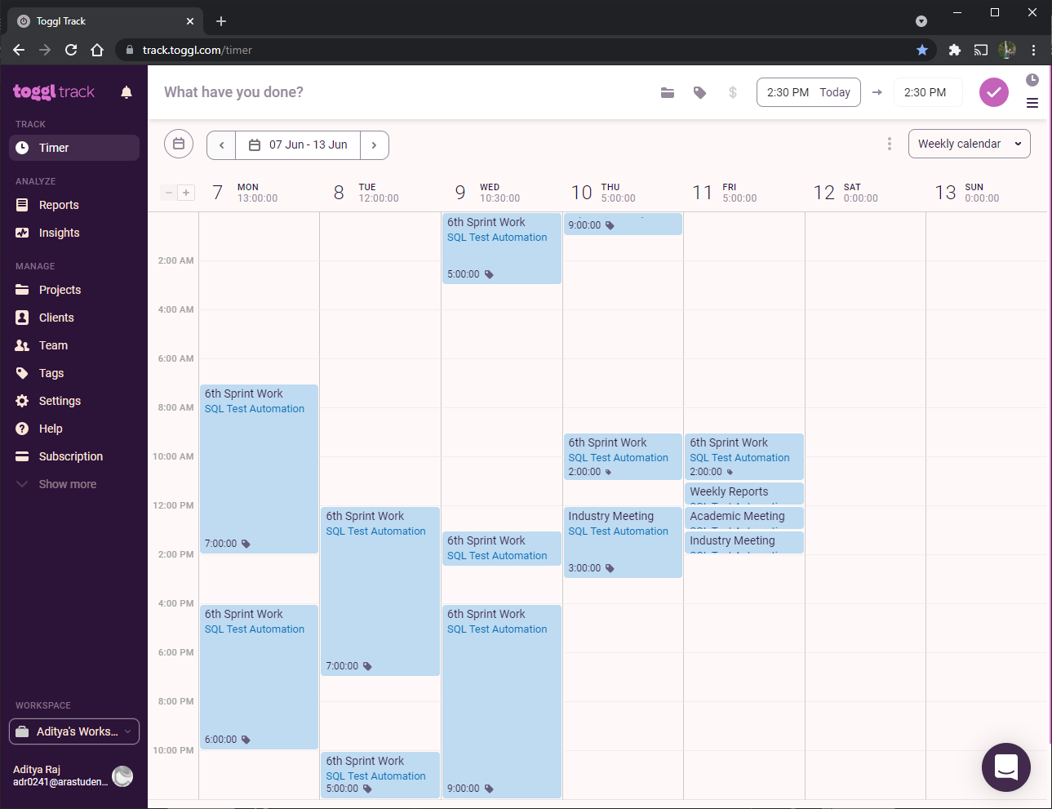

### Appendix C3 – GitHub (Code Repository)

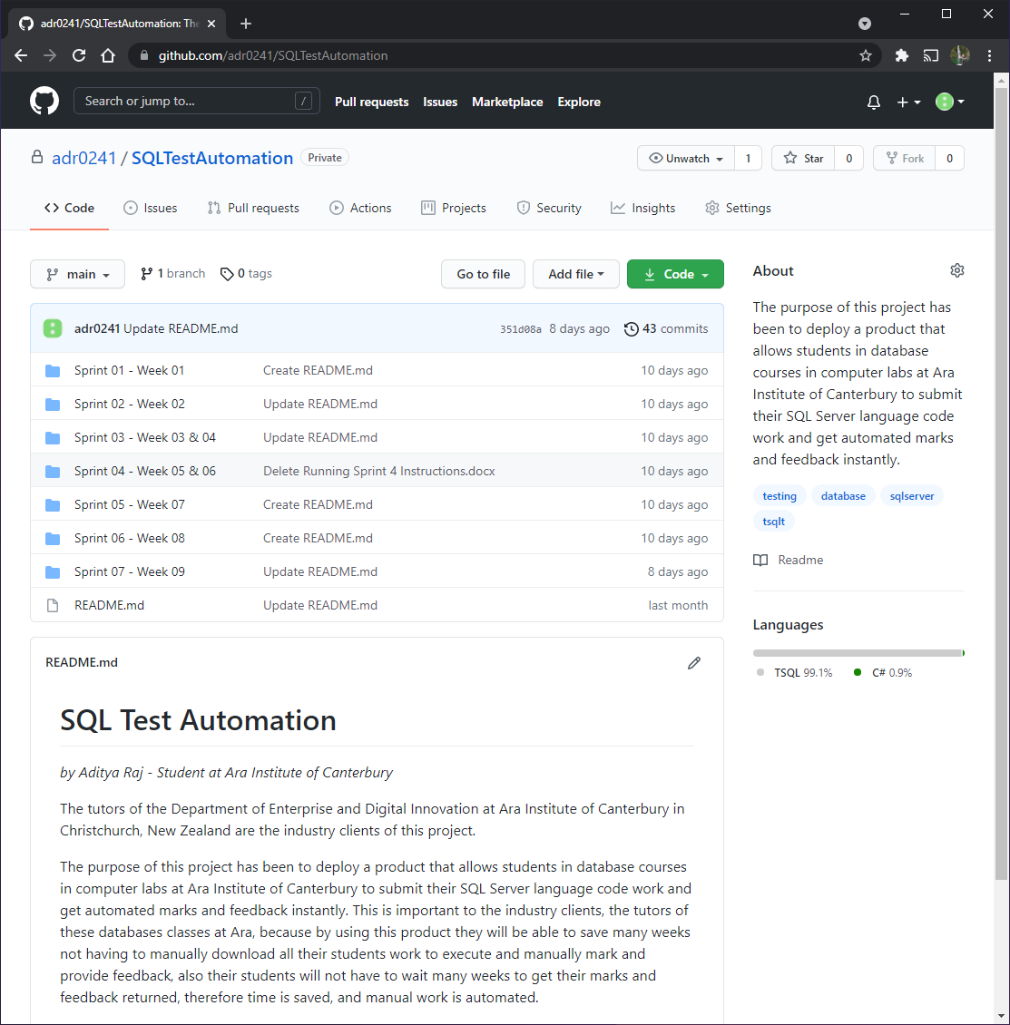

## Appendix D – Burndown Charts

### Appendix D1 – Industry Burndown



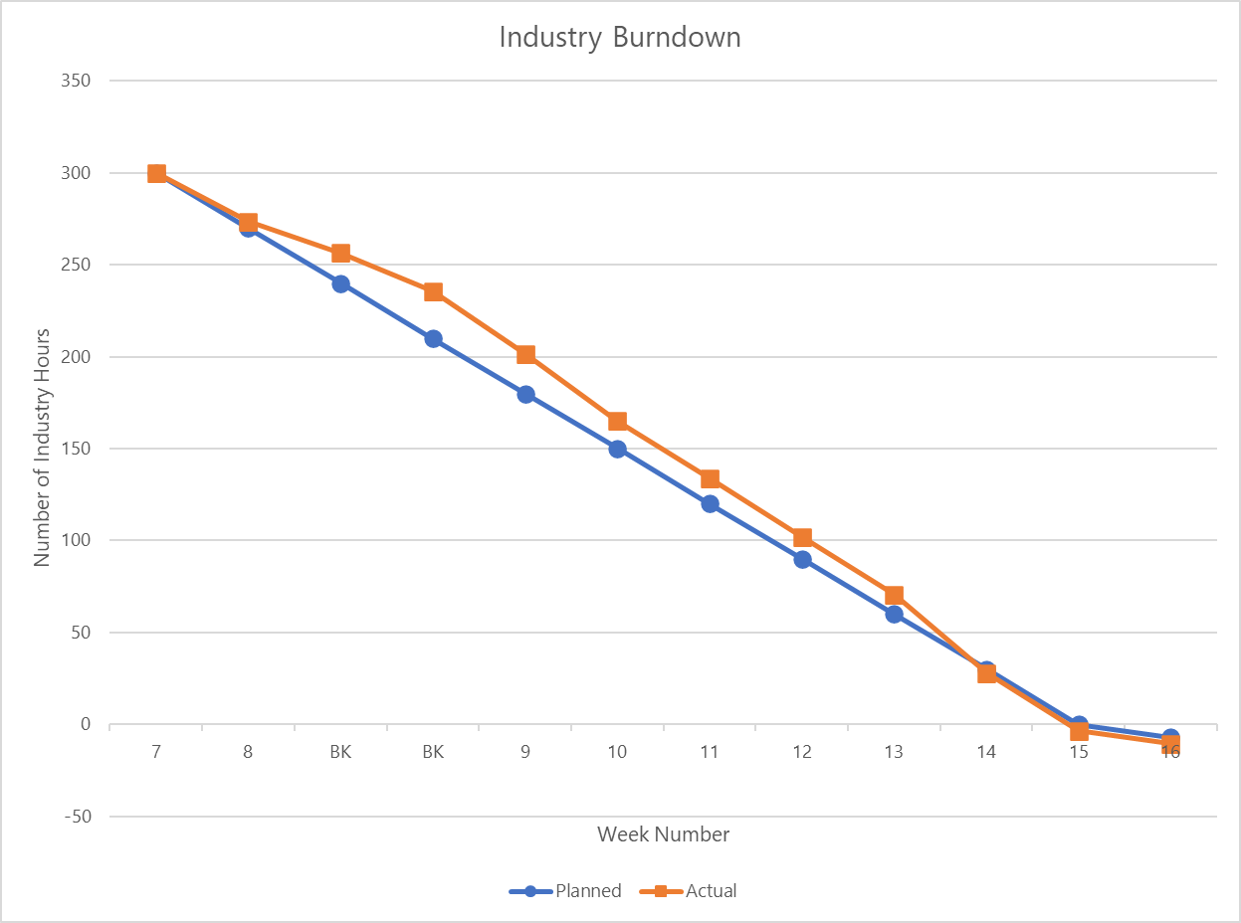

### Appendix D2 – Academic Burndown



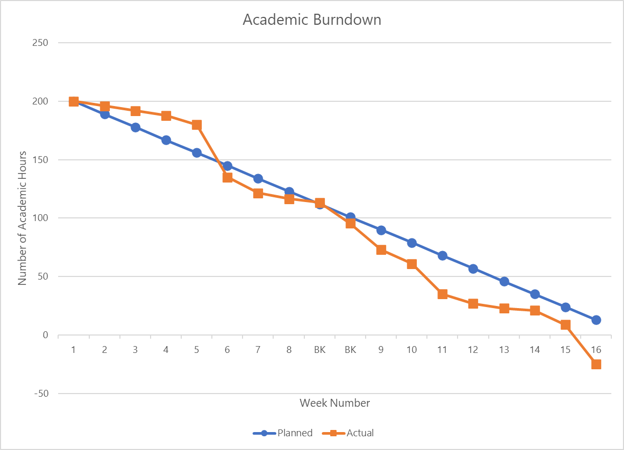

## Appendix E – Risk Management

### Appendix E1 – Initial Stage Risk Table



### Appendix E2 – Mid Stage Risk Table



### Appendix E3 – Final Stage Risk Table



## Appendix F – Quality Assurance

### Appendix F1 – Quality Assurance Table

|  |  |  |  |
| --- | --- | --- | --- |
| Deliverable | Development Phase | Success criteria/standards | Signees |
| Learning SQL Server and Testing tSQLt Framework. | Sprint 1 | All code meets SQL Server and tSQLt best programming practices and has been reviewed and tested by my industry supervisor to meet quality standards. The product produced expected results. | Amit Sarkar, Alister MacGregor |
| Create Correct and Incorrect Answer Testing Scripts for Single Question and Query - tSQLt | Sprint 2 | All code meets SQL Server and tSQLt best programming practices and has been reviewed and tested by my industry supervisor to meet quality standards. The product produced expected results. | Amit Sarkar, Alister MacGregor |
| Create Correct and Incorrect Answer Testing Scripts for Multiple Questions and Queries - tSQLt | Sprint 3 | All code meets SQL Server and tSQLt best programming practices and has been reviewed and tested by my industry supervisor to meet quality standards. The product produced expected results. | Amit Sarkar, Alister MacGregor |
| "Use Restored NORTHWND Database.  Create Testing Script using Real Course Tests - tSQLt" | Sprint 4 | All code meets SQL Server and tSQLt best programming practices and has been reviewed and tested by my industry supervisor to meet quality standards. The product produced expected results. | Amit Sarkar, Alister MacGregor |
| Create First Packaged Prototype Program using C# .NET Framework - Test Multiple Queries for One Student, Use Real Course Tests. | Sprint 5 | All code meets C# and .NET best programming practices and has been reviewed and tested by my industry supervisor to meet quality standards. The product produced expected results. | Amit Sarkar, Alister MacGregor |
| Create Second Packaged Prototype Program using C# .NET Framework - Test Multiple Queries for Multiple Students, Use Real Course Tests with Real Student Answers. | Sprint 6 | All code meets C# and .NET best programming practices and has been reviewed and tested by my industry supervisor to meet quality standards. The product produced expected results. | Amit Sarkar, Alister MacGregor |
| Create Final Portable Packaged Prototype Program using C# .NET Framework - Test Program with Second Set of Real Course Tests and Real Student Answers. Create Product Manual Documentation. | Sprint 7 | All code meets C# and .NET best programming practices and has been reviewed and tested by my industry supervisor to meet quality standards. The product produced expected results. Tested by Ara ICT Service Desk and Graduate Alliah Calla. | Amit Sarkar, Alister MacGregor |

**END OF DOCUMENT**